***“Learn to understand”***

**Group 6**

Delicano

Rabacal

Jaranilla

Jurilla

**Christian Living Education 9**

**9G**

**Submitted to:** Rainheart G. Pinuela

**Introductions of the members of the Group**

**Delicano -** My name is Jethro Delicano. I like playing basketball but most of my free time i spent it to practice playing drums. My expectations in this PT is that we can create an environment that accepts one's beliefs.

**Rabacal -** Hi, I am John Kristoff Rabacal, I like playing online games and I love listening to music. My expectations for this PT is to learn and to have clues how life should be.

**Jaranilla -** My name is Jasmene Jaranilla, I like playing mobile games and scrolling through TikTok all day. I hate physical activity, anything that would make me tired.

**Jurilla -** My name is Alina Braen Jurilla. I like playing games, reading books, and spending time with my friends whether it be online or not. My expectations for this PT is that it can hopefully be eye-opening and educating to other people who are constantly being insensitive to people.

**Introduction to the chosen issue**

**(Insensitivity)**

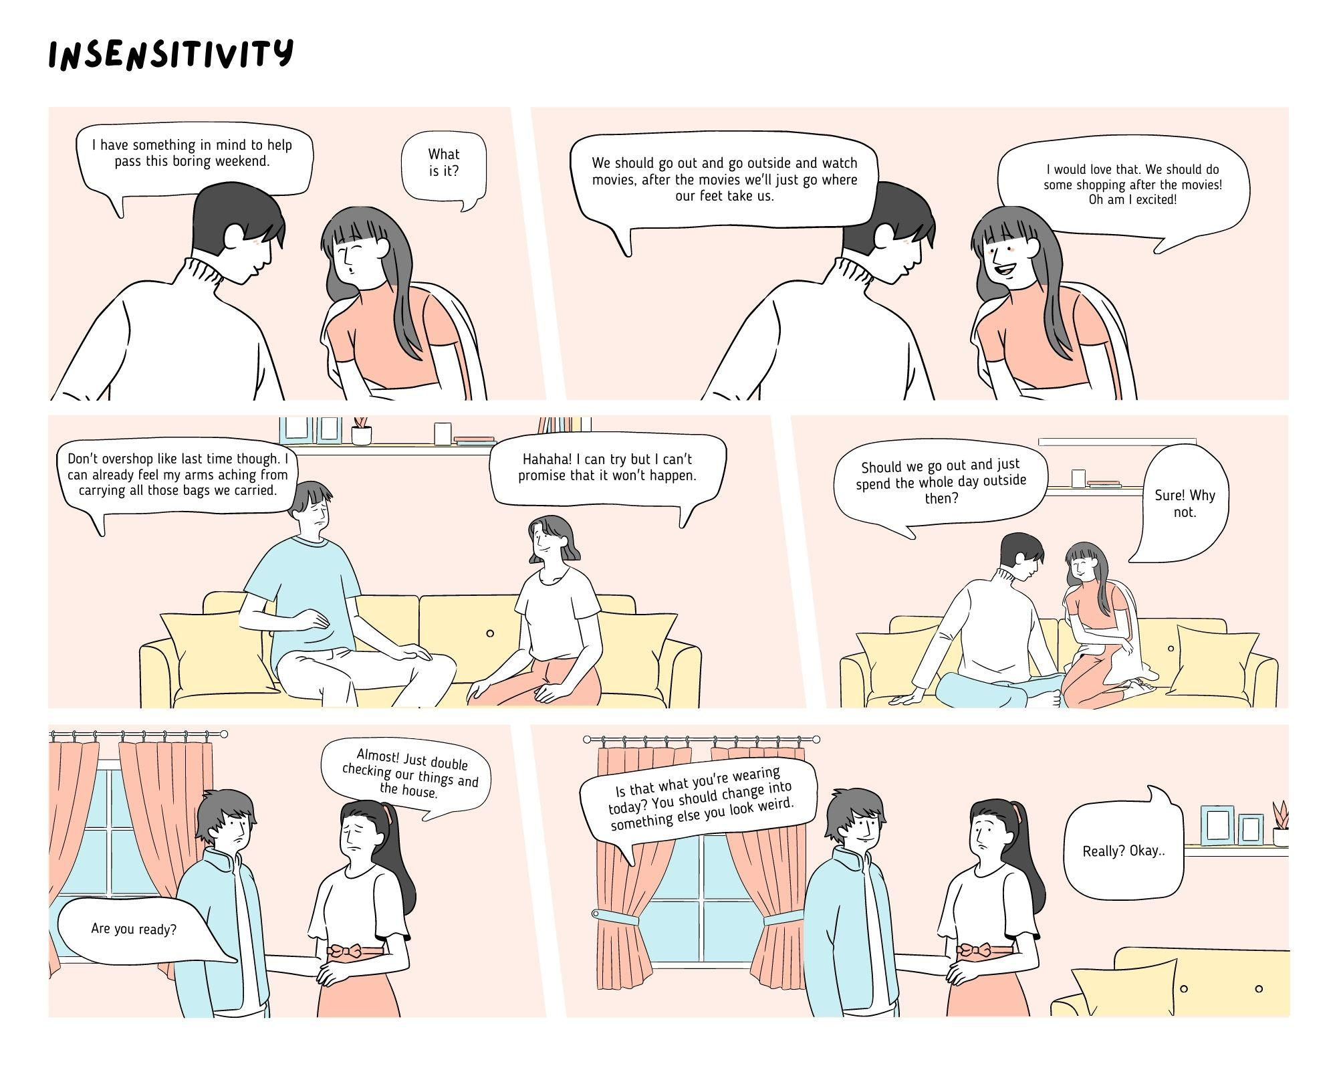

* Our comic strip shows how pointing out something to someone “as a joke” may not be a “joke” to them. Being insensitive is something a lot of people do, whether it be by accident or not, despite that being insensitive can also have its own limits. It’s most likely that being insensitive happens whenever someone points out something about you that was never a big deal to you, but now is because of someone “jokingly” pointing it out and “jokingly” teasing you about it. Many people like to do it and whenever the person they “jokingly” teased reacts negatively about it they would just make it look like it's their fault for being *too sensitive*. Even the church discourages being insensitive and being able to understand that not all the people you meet have the same type of humor as you. Not everyone is like you and how you don’t take everything people point out to you as something negative. People will always have a different type of emotional understanding with what you have said.

**Rationale**

* This topic may not be talked about as much as mental illnesses, human-rights, politics, etc. it is still a serious problem that people just brush off their shoulders. Insensitivity is quite a serious problem people do nowadays and still get away with it because it isn’t necessarily *bullying*, although I would like to think that it’s a branch of it. As mentioned before, people being insensitive can get away with it because they’ll just blame the person they had teased and say that they were “too sensitive”. Blaming someone for being “too sensitive” can take a toll on the person you blame it for and it’ll make them think that they’re too much of a killjoy or a crybaby. It won’t only affect the person mentally, but also physically and emotionally. It makes them think too much of their physical appearance and the way they act around certain people, not only is it exhausting but also draining to their mental health. Being insensitive and calling it a “joke” is not and never will be a good excuse. Being insensitive purposely is not funny and you never know what anyone is going through, the least thing that we can do is be kind and if we were to point out something to them, point it out to them privately and be understanding.

**Solutions to the chosen issue**

**(Insensitivity)**

* ***Be understanding***

As mentioned before, being understanding makes people more comfortable with you and is not afraid to ask you questions about their appearance without feeling scared that you might tease them.

* ***Question yourself “what would I feel if they told/do this to me”?***

I would always ask myself this question before telling something to my friend that seems a little bit too harsh of me to say. But also whenever you ask yourself this question before telling your friend is already a sign itself that you shouldn’t tell it.

* ***Learn to apologize for your mistakes and learn from it***

Just like school, learn to apologize and learn from your mistakes. People will always understand that you didn’t mean to say it, especially if you didn’t know or was not informed of it. So don’t make it a habit to throw the blame on someone else instead of yourself.

* ***Know the limitations of a person***

One of the many steps to start and be less insensitive is to know the limitations of a person, especially your friends’. Know that not everyone isn’t like you and some have more limitations in their life unlike you.

* ***Be able to empathize***

Although I understand that being able to empathize with someone can be quite difficult, as long as you show to your friend that you’re trying your best they will always appreciate the effort you put in.

**Objectives**

* ***You will never know what someone is truly going through***

Not everything that your friend tells you is *everything* that happened to them. So understand that all you have to do is be kind and understanding to them because that might help brighten their day.

* ***Understand that they don’t tell you everything for a reason***

Connected to the first objective, don’t pressure your friend because they can’t tell you why they can’t tell you. They genuinely would tell you what had happened that they can’t tell you but they thought it was best that you wouldn’t know and that’s good enough reason to not pressure them to tell you.

* ***Respect***

At the end of it all, what matters the most is that you respect your friend. Whether it be personal life, opinions, emotions, etc. you should still respect them because that’s what makes them unique.

**Prayer**

God our Father we pray to you for the betterment of everyone. Guide us and help us learn throughout our lives, may you forgive us for the sins that we may have and will make throughout. May you let us understand what we need to learn. Protect us from all dangers that will come our way. Help us to see the bigger pictures in life and bless us with strength, courage, and understanding. Through our Lord Jesus Christ your Son, who lives and reigns with You in the unity of the Holy Spirit one God forever and ever, Amen.

**Acknowledgments**

We firstly acknowledge the patience and understanding of our teachers so that we can be able to still pass our work. We also acknowledge the amount of work our leader has also given to our project. Also the effort our groupmates have made so that we could finish our PT with ease because of their ongoing cooperation and dedication to helping the leader finish the project. Finally, we also acknowledge and thank God for guiding every single one of us so that we were able to finish our work with sincerity and not just for the sake of passing it.